Missionaries and Cannibals Problem
Aim:
To safely transport all missionaries and cannibals across the river without violating the constraints.
Procedure:
- Start with all missionaries and cannibals on one side.
- Move people using the boat according to the rules.
- Ensure missionaries are never outnumbered by cannibals.
- Repeat until everyone reaches the opposite bank.
- Display the sequence of moves.
Output:
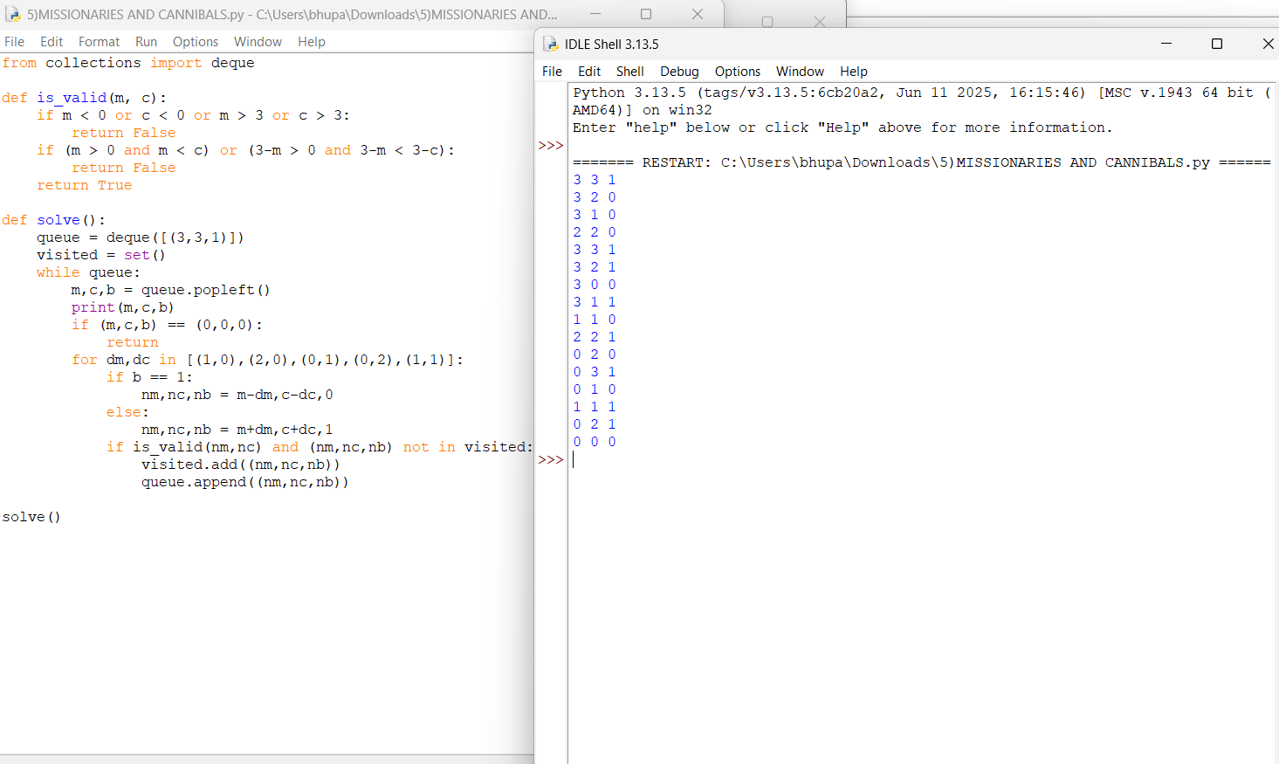
Result:
All missionaries and cannibals crossed the river safely.

